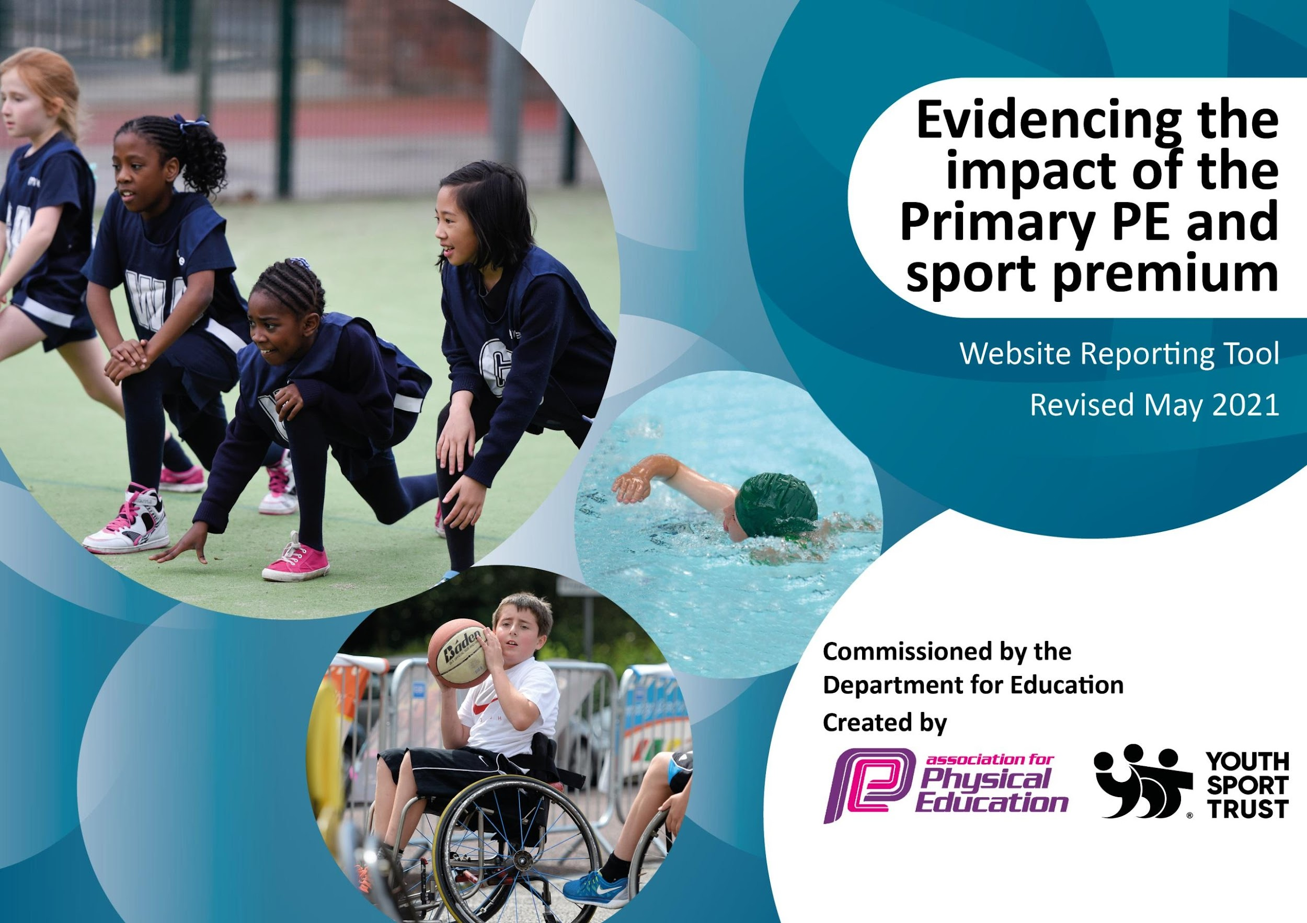

It is important that your grant is used effectively and based on school need. The Education Inspection Framework (Ofsted 2019 p64) makes clear there will be a focus on ‘whether leaders and those responsible for governors all understand their respective roles and perform these in a way that enhances the effectiveness of the school’.

Under the Quality of Education criteria (p41) inspectors consider the extent to which schools can articulate their curriculum (INTENT), construct their curriculum (IMPLEMENTATION) and demonstrate the outcomes which result (IMPACT).

To assist schools with common transferable language this template has been developed to utilise the same three headings which should make your plans easily transferable between working documents.

Schools must use the funding to make additional and sustainable improvements to the quality of Physical Education, School Sport and Physical Activity (PESSPA) they offer. This means that you should use the Primary PE and sport premium to:

- Develop or add to the PESSPA activities that your school already offer
- Build capacity and capability within the school to ensure that improvements made now will benefit pupils joining the school in future years
- The Primary PE and sport premium should not be used to fund capital spend projects; the school’s budget should fund these.
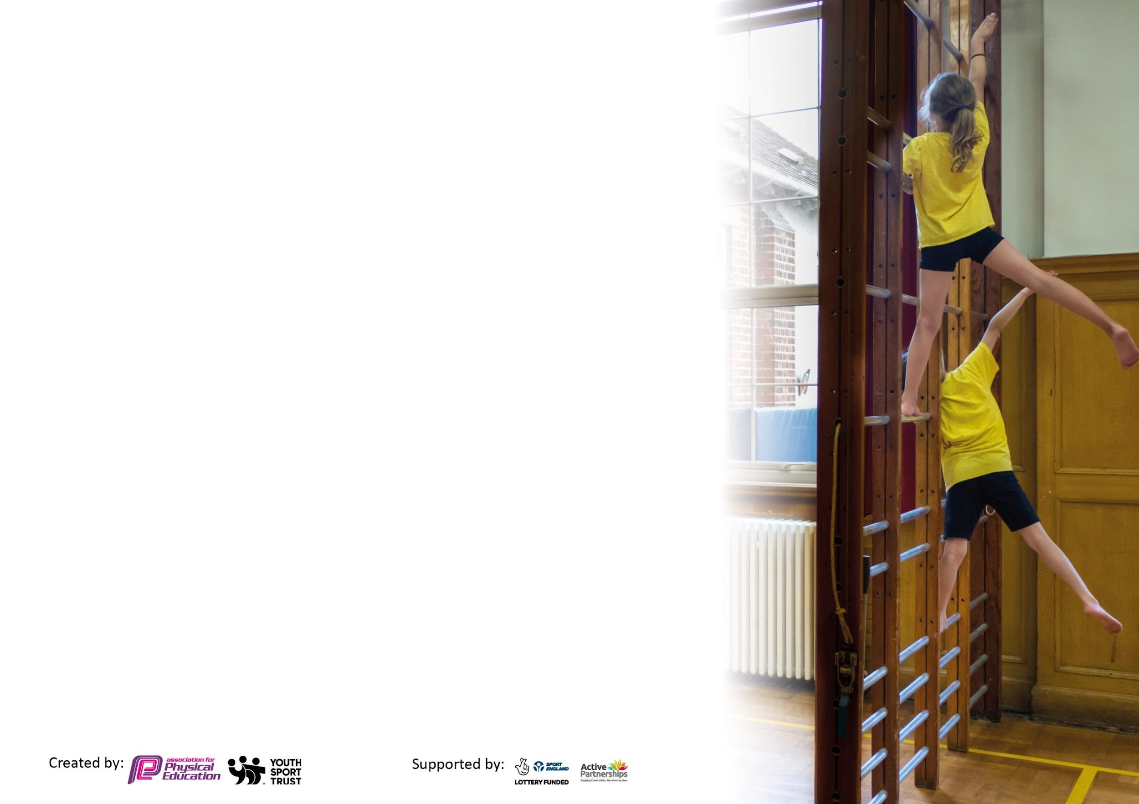
Please visit gov.uk for the revised DfE guidance including the 5 key indicators across which schools should demonstrate an improvement. This document will help you to review your provision and to report your spend. DfE encourages schools to use this template as an effective way of meeting the reporting requirements of the Primary PE and sport premium.

We recommend you start by reflecting on the impact of current provision and reviewing the previous spend.

Schools are required to publish details of how they spend this funding, including any under-spend from 2019/2020, as well as on the impact it has on pupils’ PE and sport participation and attainment by the end of the summer term or by 31st July 2021 at the latest.

We recommend regularly updating the table and publishing it on your website throughout the year. This evidences your ongoing self-evaluation of how you are using the funding to secure maximum, sustainable impact. Final copy must be posted on your website by the end of the academic year and no later than the 31st July 2021. To see an example of how to complete the table please click HERE.

Please note: Although there has been considerable disruption in 2020 it is important that you publish details on your website of how you spend the funding - this is a legal requirement.

Support for review and reflection - considering the 5 key indicators from DfE, what development needs are a priority for your setting and your pupils now and why? Use the space below to reflect on previous spend and key achievements and areas for development.

N.B. In this section you should refer to any adjustments you might have made due to Covid-19 and how these will influence further improvement.
Key achievements to date until July 2020: | Areas for further improvement and baseline evidence of need:
- Years 1-6 have started to embed the use of the ‘Champions’ PE Scheme of work so staff are teaching PE with more structure and confidence. Teachers have been continued to be supported by a PE lead teaching assistant.  - PE equipment and playground active equipment (for each class bubble) has been purchased.  - Teachers have promoted physical activity in their classrooms especially after Covid 19 to combat inactivity during lockdown and mental health.  - Sports Day has been organised for individual bubbles to promote sport and competition.  - Some year groups have taken part in Virtual competitions against other schools.  - Despite covid and flood disruption (unable to use hall), PE lessons have been delivered weekly outdoors.  - Sports after-school clubs within bubbles were offered in Autumn 2020 and Summer 2. | - We would hope to get back to taking part in face-face competitions at Orford hub and BCA next academic year.  - There will be a return to regular sporting clubs after school that we can offer to the whole of KS2 rather than class bubbles as this limits numbers.  - We hope to return to indoor lessons especially in winter to offer full coverage of the curriculum including gymnastics and dance and new equipment will be purchased to enhance this provision.  - Swimming lessons has been prioritised for all year groups in Key stage 2 to ensure that children are meeting requirements of swimming 25 metres by the time they leave Meadowside Primary.  - We will book in an experience day where outside providers will come in to deliver health and well-being lessons for the children.

Did you carry forward an underspend from 2019-20 academic year into the current academic year? YES
Total amount carried forward from 2019/2020 £7414.58
+ Total amount for this academic year 2020/2021 £17,860.00
= Total to be spent by 31st July 2021 £25,274.58

Meeting national curriculum requirements for swimming and water safety.

N.B Complete this section to your best ability. For example you might have practised safe self-rescue techniques on dry land which you can transfer to the pool when school swimming restarts.
Due to exceptional circumstances priority should be given to ensuring that pupils can perform safe self rescue even
if they do not fully meet the first two requirements of the NC programme of study.
What percentage of your current Year 6 cohort swim competently, confidently and proficiently over a distance of at least 25 metres?  N.B. Even though your pupils may swim in another year please report on their attainment on leaving primary school at the end of the summer term 2021.  Please see note above. | 27%
What percentage of your current Year 6 cohort use a range of strokes effectively [for example, front crawl, backstroke and breaststroke]?  Please see note above. | 27%
What percentage of your current Year 6 cohort perform safe self-rescue in different water-based situations? | 27%
Schools can choose to use the Primary PE and sport premium to provide additional provision for swimming but this must be for activity over and above the national curriculum requirements. Have you used it in this way? | No

Action Plan and Budget Tracking
Capture your intended annual spend against the 5 key indicators. Clarify the success criteria and evidence of impact that you intend to measure to evaluate for pupils today and for the future.

Academic Year: 2020/21 | Total fund allocated: £13,654.57  Carry forward to 2021-22  £11,620.01 | Date Updated: 23rd July 2021
Key indicator 1: The engagement of all pupils in regular physical activity – Chief Medical Officers guidelines recommend that primary school pupils undertake at least 30 minutes of physical activity a day in school |  |  |  | Percentage of total allocation:
 |  |  |  | 6%
Intent | Implementation |  | Impact
Your school focus should be clear what you want the pupils to know and be able to do and about  what they need to learn and to  consolidate through practice: | Make sure your actions to achieve are linked to your intentions: | Funding allocated: | Evidence of impact: what do pupils now know and what can they now do? What has changed?: | Sustainability and suggested next steps:
To encourage and promote physical activity starting with our youngest children in EYFS by developing the EYFS PE scheme using the ‘Development Matters’ document.  To promote more outdoor physical activity especially after lockdown including entitlement to outdoor PE lessons as well as playtime physical activities and the offer of sports clubs after school.  To purchase more sports equipment to ensure the Scheme of Work can be fully followed and to promote physical activity at playtime and lunchtime. | EYFS all take part in regular PE lessons using the ‘Develop matters’ document to deliver well-structured lessons promoting physical activity.  All PE lessons have been outdoor this year following the Champions scheme of work. Children have enjoyed rounder, athletics, cricket, tennis, basketball and lots of throwing and catching skills.  Y1/2 have taken part in scooter training.  Y5/6 have taken part in bikeability.  Classes regularly take outdoor active breaks.  KH delivered sports clubs x3 per week in Autumn term.  KH delivered sports club to Y3 in Summer 2.  AF deliver dance club to Y2 in Summer 2.  Sports equipment has been purchased to promote more active play outside, each class was given a box of equipment in Sept 2020 for their class to use at playtimes and lunch.  A class set of 15 footballs have been purchased for each class and tennis balls to promote throwing and catching element of the curriculum. | £300  Playground equipment  £256.45  Sports equipment  £142.08  Tennis balls £58  Skipping ropes £40  Space markers £60 | Through pupil voice, EYFS children understand that exercise helps them to stay healthy and fit.  Pupil voice – children have tried out a variety of different sports in PE lessons.  Children at Meadowside enjoy physical activity at lunchtime and play although they do like to have a bit of relaxing time too.  Pupil Voice – Children enjoy after school sports clubs and are looking forward to offer of more next academic year. | After CPD with Beccy Cresswell, all classes will be supported with ideas of an active classroom (whole school CPD booked in Nov 2021)  Sports clubs to be up-and -running in Autumn term, hopefully available to whole of Key Stage instead of class bubbles.  MDA training provided by Warrington Sports Partnership.
Key indicator 2: The profile of PESSPA being raised across the school as a tool for whole school improvement |  |  |  | Percentage of total allocation:
 |  |  |  | 2%
Intent | Implementation |  | Impact
Your school focus should be clear what you want the pupils to know and be able to do and about  what they need to learn and to  consolidate through practice: | Make sure your actions to achieve are linked to your intentions: | Funding allocated: | Evidence of impact: what do pupils now know and what can they now do? What has changed?: | Sustainability and suggested next steps:
To work alongside TCAT to increase competitions within the academy trust.  To raise awareness of competitive sport through our sports partnership (part of SLA Agreement)  Provide top-ups for Y6 in Summer term depending on government guidelines due to Covid 19. | Meadowside Primary took part in Comic Relief Dance for TCAT.  Each class practiced a repetitive line dance as part of their dance element of the PE curriculum. Children were videoed and it was published on Twitter promoting our collaboration of PE within the trust.  Giant Redwoods took part in a virtual Boccia competition against other Warrington schools.  Y3 took part in an athletics virtual competition against other Warrington schools.  Due to Covid, we were unable to fulfil this target this academic year and plan to rectify this next year. | £280  School Games (part of SLA Agreement) | This has been quite difficult to fulfil due to Covid.  Children really enjoyed the completion element in their PE lessons when asked.  This is to be a priority for next year. | To sign up for at least one competition per term through the WASSPs website from September.  Swimming lessons are booked for Spring and Summer term 2022 at Swim for all year groups in Key Stage 2.

Key indicator 3: Increased confidence, knowledge and skills of all staff in teaching PE and sport |  |  |  | Percentage of total allocation:
 |  |  |  | 87%
Intent | Implementation |  | Impact
Your school focus should be clear | Make sure your actions to | Funding | Evidence of impact: what do | Sustainability and suggested
what you want the pupils to know | achieve are linked to your | allocated: | pupils now know and what | next steps:
and be able to do and about | intentions: |  | can they now do? What has
what they need to learn and to |  |  | changed?:
consolidate through practice:
To continue to develop the confidence in the medium term plans and objectives for each teacher’s year group to ensure that we can see clear progression throughout the school in PE lessons.  PE lead to take part in CPD to ensure PE is promoted and taught well and safely at Meadowside. | Clear medium term plans were written and made available by the PE Lead.  A road map of progression in PE is on the school website.  Through staff meeting, teachers have expressed their confidence in the scheme of work purchased.  KH continued to support in PE lessons across the school  AF completed PE Leadership day in Sept 2020.  AF joined regular after school CPD provided by LiveWire Sports Partnership.  AF completed APfe Safety Course in PE.  AF took part in CPD with Beccy Cresswell on active learning in the classroom 12/7/2021 | £10,826.04  £925  Live Wire (part of SLA Agreement) | Due to Covid, PE Lead unable to monitor lessons but through Staff Voice and Pupil voice, it is clear that children and adults are feeling safe, confident and understand the importance of physical activity through their PE lessons. | To observe and monitor PE lessons once covid bubble restrictions are lifted.  Monitor if active learning is taking place in classrooms and the impact it is having on learning.  Beccy Cresswell to provide CPD on active learning for whole school in November staff meeting 2021.
Key indicator 4: Broader experience of a range of sports and activities offered to all pupils |  |  |  | Percentage of total allocation:
 |  |  |  | 3%
Intent | Implementation |  | Impact
Your school focus should be clear | Make sure your actions to | Funding | Evidence of impact: what do | Sustainability and suggested
what you want the pupils to know | achieve are linked to your | allocated: | pupils now know and what | next steps:
and be able to do and about | intentions: |  | can they now do? What has
what they need to learn and to |  |  | changed?:
consolidate through practice:
Additional achievements:  To offer a range of sports in our PE lessons  To offer a range of sports in the form of After-school clubs to be provided in Year groups following government guidelines in KS2  To provide sports clubs after school for KS1 in Summer term as they missed out last year due to lockdown. | Teachers following Champions scheme of work which promotes a range of sports and through the road map created in July 2020, this also ensures a broad range of sports being offered.  WASSPs provided some PE lessons when we were in lockdown in February at BCA.  Warrington Wolves Foundation provided virtual lessons whilst we were in lockdown Jan-March 2021.  KH – Delivered 3 x sports clubs per week in Autumn term.  AF - Dance Club delivered to the Y2 bubble | £550  WASSPs (part of SLA Agreement) | When asked, children have listed a range of sports that they have covered in PE and have enjoyed their PE lessons.  Pupil Voice – children have suggested some sports that they think will be popular for after school clubs in September. Children at Meadowside are keen to take part in after school sports.  AF had 13 children regularly taking part in Y2 dance club. Parents on dojo expressed that their child enjoyed the club. | Continue to carry out Pupil voice to ensure sport children want to do are delivered.  After school clubs to be run hopefully with no bubble restrictions in place so can have KS2 clubs.  To provide KS1 clubs in summer term.

Key indicator 5: Increased participation in competitive sport |  |  |  | Percentage of total allocation:
 |  |  |  | 2%
Intent | Implementation |  | Impact
Your school focus should be clear | Make sure your actions to | Funding | Evidence of impact: what do | Sustainability and suggested
what you want the pupils to know | achieve are linked to your | allocated: | pupils now know and what | next steps:
and be able to do and about | intentions: |  | can they now do? What has
what they need to learn and to |  |  | changed?:
consolidate through practice:
Increase the profile of competition across school by:  To get involved with TCAT Primary competition in 2020-21.  To promote more in-house competitions due to Covid 19.  To book experience days if Govt guidelines allow. | This has not been possible due to restrictions.  Sport Day 2021 has been organised by the PE Lead for Y1-6 on 7.7.2021, Designated provision classes on 9.7.2021 and EYFS on 14.7.2021.  This was unavailable due to covid restrictions. | Stickers for sports day  £17  Markings for sports day  £200 | Children have been able to take part in a sporting event albeit in class bubbles and not in front of parents. Children encouraged to show good sporting attitudes and encouraged to try their best. | To take part in local competitions in Orford if covid restrictions allow.  To have a PE day in Spring Term to coincide with Sports Relief on 17th March 2022.  Book on ‘experience days’ to promote physical health and mental health for children. AF in process of organising an experience day with Beccy Cresswell.

Signed off by
Head Teacher: | Stuart Wright
Date: | 23/7/21
Subject Leader: | Alison Fowler
Date: | 23/7/21
Governor: | Phil Calrow
Date: | 23/7/21

